Task 8.2: Program Design

**Structure Chart**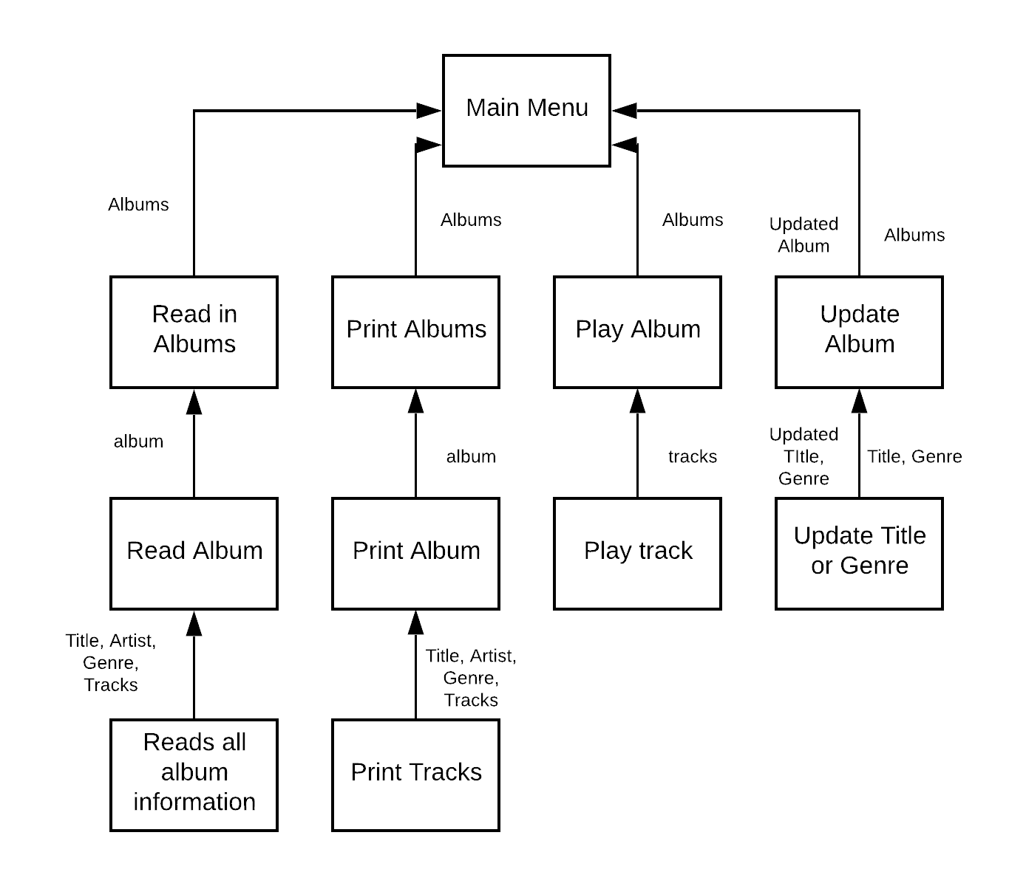

**Short Summary:**

The music player I have created takes in a list of albums from an albums file and stores them in serval arrays that are accessed throughout the program.

|  |  |
| --- | --- |
| **Array** | **Records inside array** |
| Albums | Stores a list of albums from the albums.txt file |
| Album | Which stores title, artist, genre, tracks of each individual album from the albums array |
| Track | Which stores the track name and location of each track from the album from the album array |

**Sequence:**

* Sequencing is shown throughout the program as one action leads to another; from the start of the program the user is prompted with a main menu. Choosing an option on the menu will lead to its own sequence of events (as shown in the structure chart above). These events must be completed in this order for the program to function correctly.

**Selection:**

* The user is presented with many selections throughout the program, depending on the input of the user the program will preform an action. Such as choosing the program which file to read albums from, depending on the input from the user the program will have different albums stored (‘albums.txt’ ≠ ‘album.txt’)

**Iteration:**

* An iteration is a pass through a loop. In this program we only use while loops (pre-test), this is because the conditions have to be met in order for the loop to execute. Such as there needs to be more than 0 tracks in the albums file, otherwise the program will not execute the read_tracks while loop and the program will not store any tracks.

**Coupling:**

* The coupling of classes in this program is low as changing something in on class shouldn’t affect the other class. There are two classes present in this program (Album, Track) since these two classes are separate the program has a low coupling.